Vineland High School
Service Learning Handbook

2019 - 2020

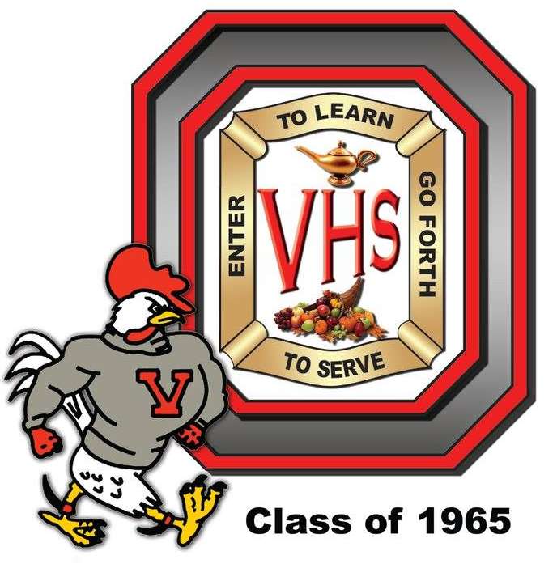

“Anyone Can Be Great…..Because Anyone Can Serve”

SERVICE LEARNING INITIATIVE
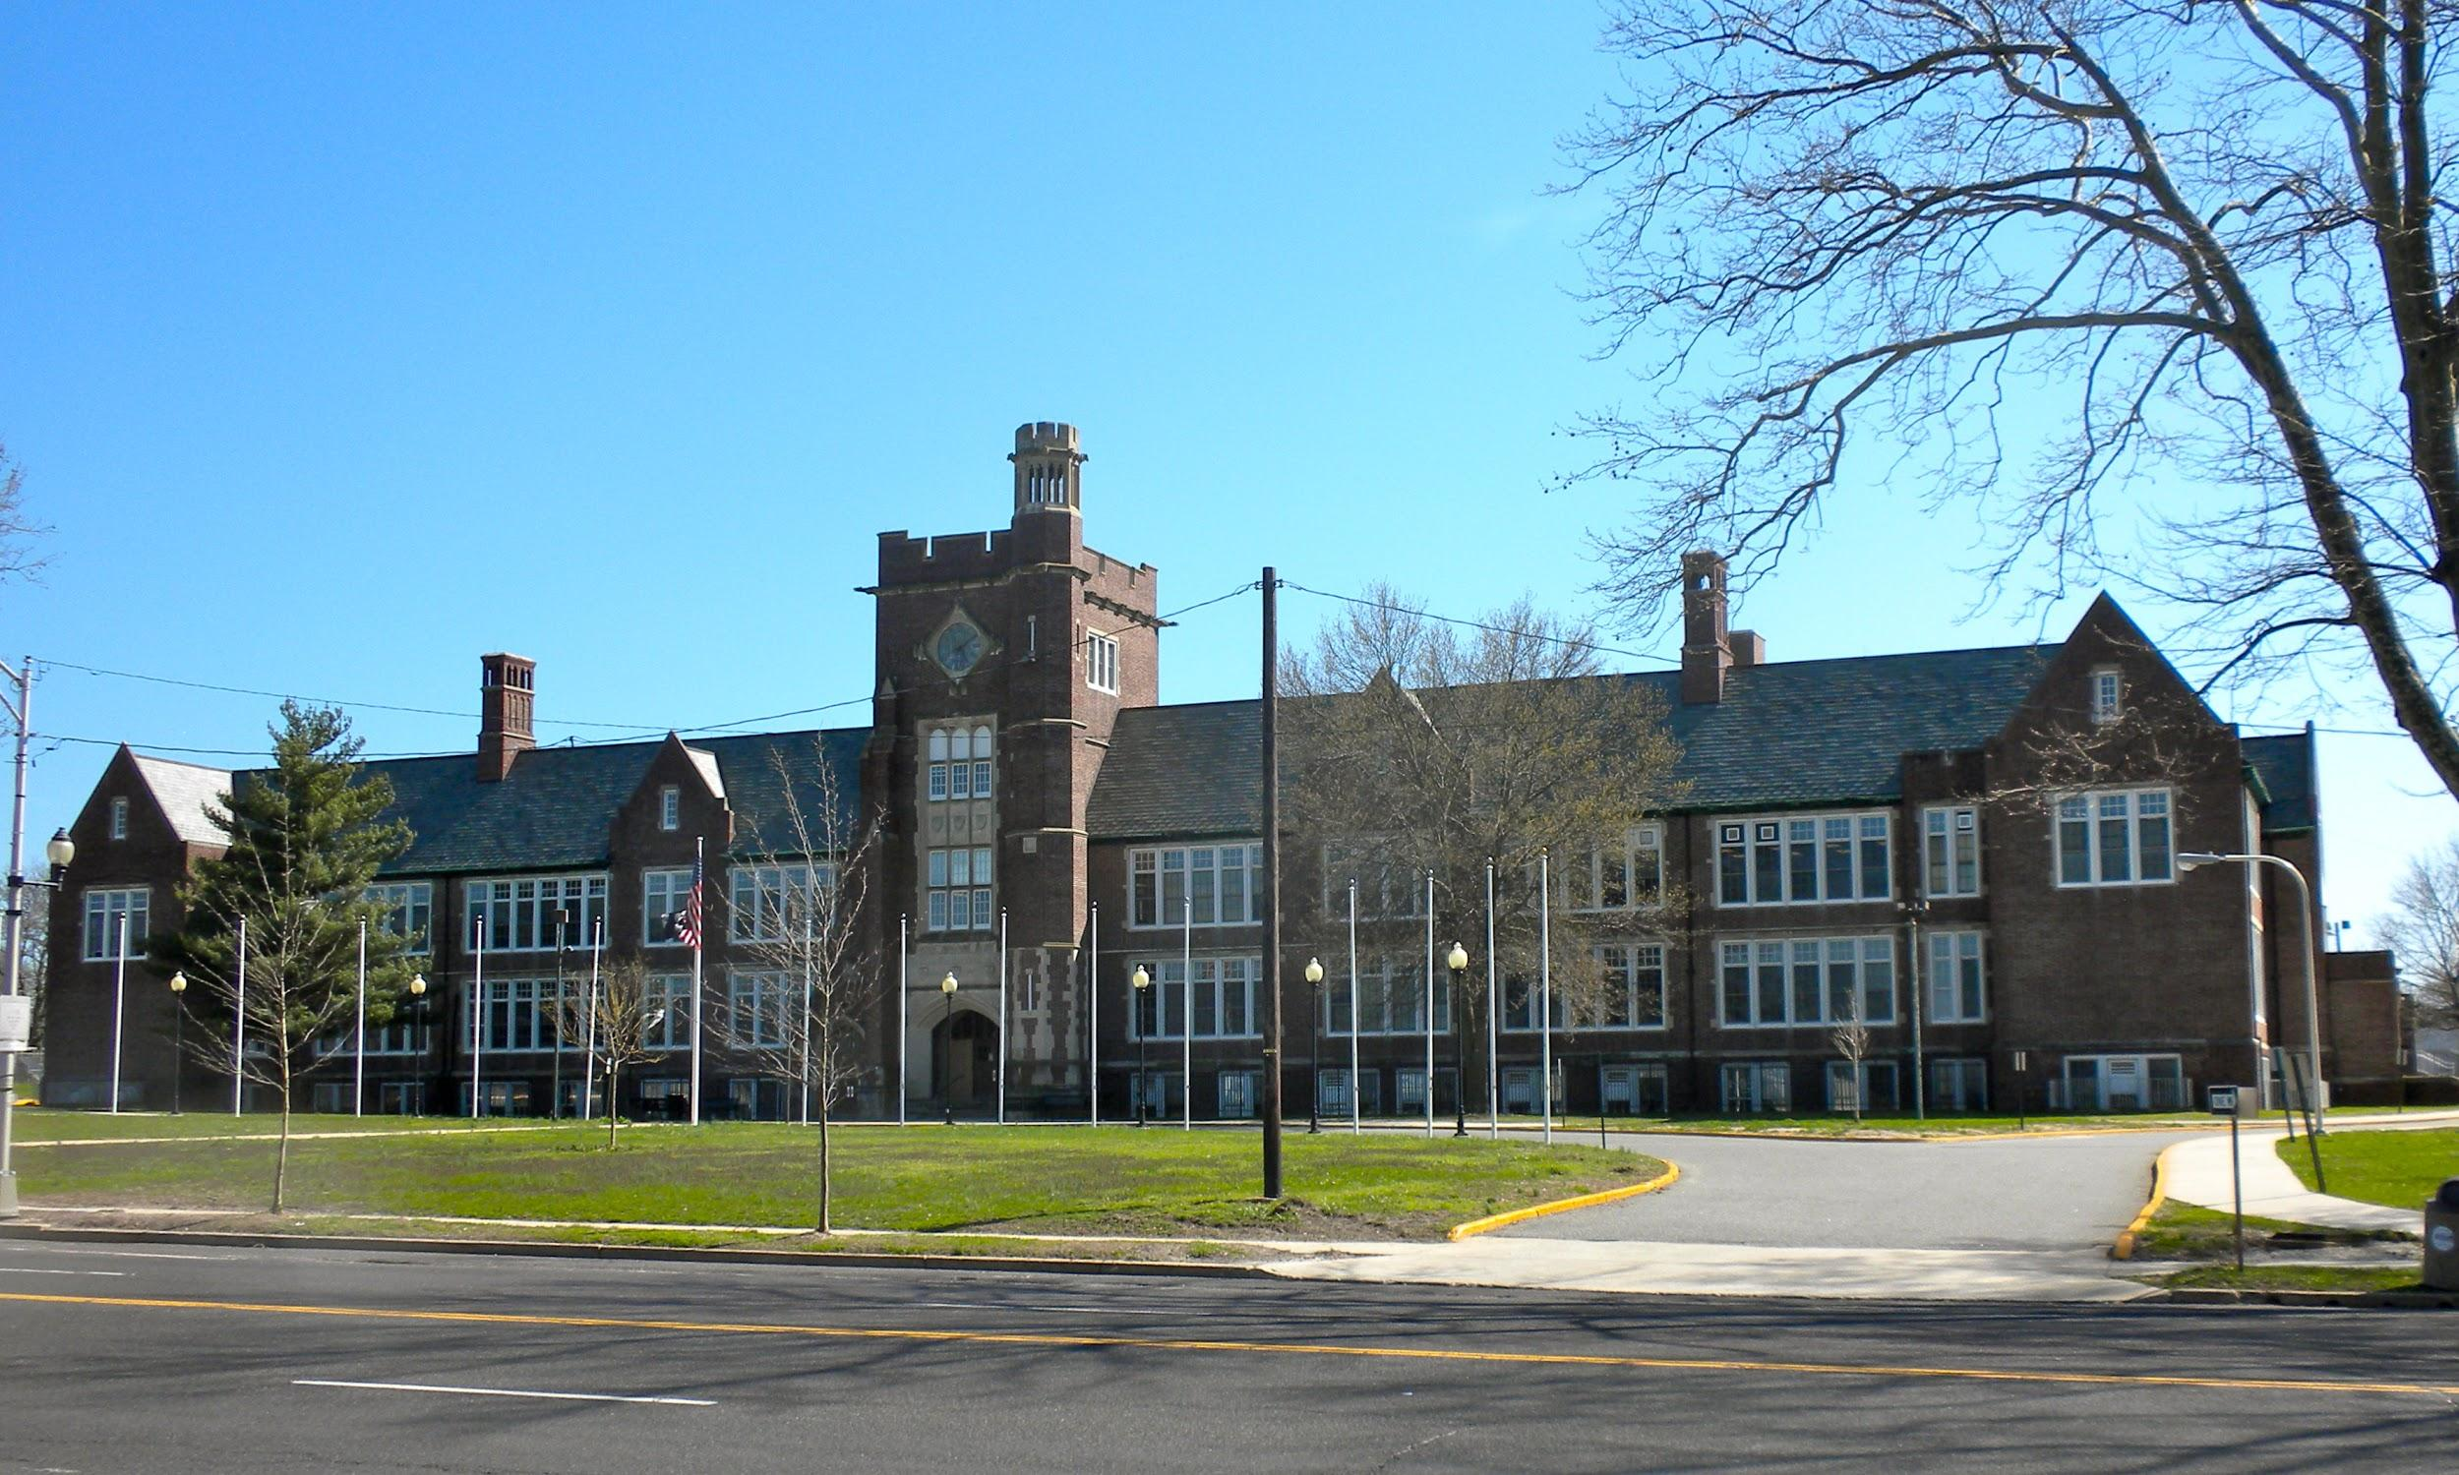
AN OVERVIEW
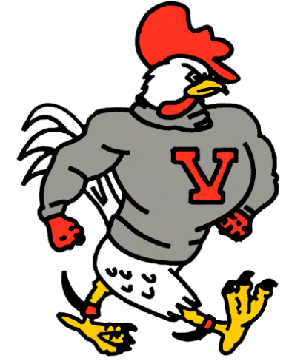

The Service Learning Initiative seeks to provide academic, social, career, and personal outcomes in accordance with the mission of Vineland Public Schools. The program presents opportunities for students to apply the knowledge, skills and strategies acquired through curricular and co-curricular opportunities to community based projects, programs, and activities with instruction and reflection that enriches the learning experience, teaches civic responsibility, and strengthens the community. This will enable students to become knowledgeable, skillful, life-long learners who are contributing citizens in our changing society.

By giving back to our community and our school we develop pride in our city and ourselves, and we develop a better understanding of our city’s strengths and weaknesses. We believe Service Learning will help our students gain an understanding of what it means to be an active, upstanding citizen.

Beginning with the class of 2022, service-learning was identified as a requirement for graduation at Vineland High School.

WHY DISTRICTS, SCHOOLS, AND CLASSROOMS
SHOULD PRACTICE SERVICE-LEARNING

Service-Learning…

leads to engagement and effective instruction.
helps academic improvement and higher order thinking skills.
fosters the development of important personal and social skills.
develops stronger ties to schools, communities and society.
promotes exploration of various career pathways.
is associated with positive school environments and more community support for schools.
provides valuable work experience to students.

Source: RMC Research Corporation. (2007). “Why districts, schools, and classrooms should practice service-learning.” Scotts Valley, CA: National Service-Learning Clearinghouse. Retrieved from http://servicelearning.org/instant_info/fact_sheets/k-12_facts/why/

WHAT IS SERVICE LEARNING?

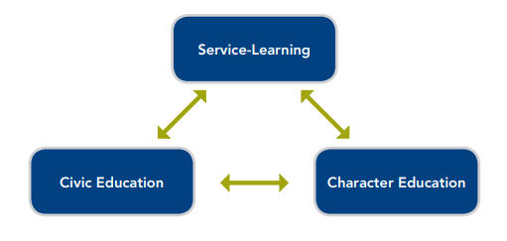

What is Service Learning?
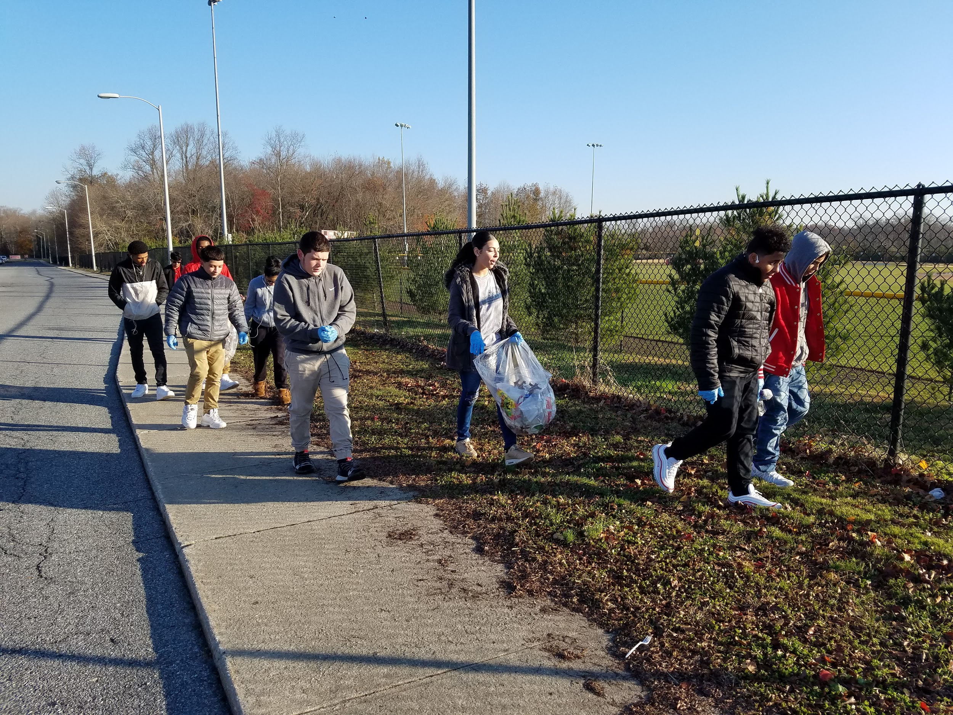
A way of teaching and learning that connects positive and meaningful action in the community with academic learning, personal growth and civic responsibility. Service-Learning helps develop citizenship and good character while providing direct connections to the academic curriculum.

What is Civic Education?
Curriculum and teaching strategies that give students the knowledge, skills, virtues, and confidence to actively participate in democratic life.

What is Character Education?
The deliberate effort for people to understand, care about and act upon core ethical values.

TYPES OF SERVICE LEARNING WITH EXAMPLES
Service-Learning is more than just simple volunteering. In the process of service to their school and/or community, students learn a lot about themselves and their responsibilities as a citizen while making connections with what they are learning in school. The following list created by the National Service-Learning Clearinghouse gives a sense of the many ways students can apply instruction and practice needed skills through helping others.

Direct Service-Learning: person-to-person, face-to-face service projects in which the students’ service directly impacts individuals who receive the service from the students. Examples include
- Tutoring other students and adults
- Conducting art/music/dance lessons for youth
- Giving presentations on violence and drug prevention
- Helping in a homeless shelter
- Creating life reviews for Hospice patients

Indirect Service-Learning: working on broad issues, environmental projects, or community development–projects that have clear benefits to the community or environment, but not necessarily to individually identified people with whom the students are working. Examples include
- Compiling a town history
- Restoring historic structures or building low-income housing
- Planting trees in collaboration with the Vineland Environmental Commission.
- Promoting school pride through various campus beautification projects

Research-Based Service-Learning: gathering and presenting information on areas of interest and need–projects that find, gather, and report on information that is needed as determined by Community partners. Examples include
- Writing a guide on available community services and translating it into Spanish and other languages of new residents
- Preserving photos and artifacts of historical Vineland for the Vineland Historical and Antiquarian Society
- Gathering information and creating brochures or videos for non-profit or government agencies

Advocacy Service-Learning: educating others about topics of public interest–projects that aim to create awareness and action on some issue that impacts the community. Examples include
- Planning and putting on public forums on topics of interest in the community
- Conducting public information campaigns on topics of interest or local needs
- Working with elected officials to draft legislation to improve communities
- Creating and implementing school based Public Service Announcements.
Source: https://uca.edu/servicelearning/types/

SERVICE-LEARNING EXPERIENCE
STUDENT PROCESS
In quality Service-Learning experiences, students participate in the following five components:

Investigation [1st marking period]
- Identify a need or area of interest in your school or community.
- Contact a Service-Learning Provider (this could be a community agency, an organization, a club or a teacher
advisor) who currently addresses the need or area of interest you have identified to gather additional
information.
- Download, print, and complete the SERVICE LEARNING PLANNING FORM

Preparation and Planning [1st marking period]
- Work with your selected Service-Learning Provider(s) to identify specific duties that would be expected of you.

Action [2nd and 3rd marking period]
- Continue your reflections throughout your time of service.
- Document your service hours and activities in the Service-Learning Log
- Complete your commitment and submit a copy of the service learning student log to your school counselor.
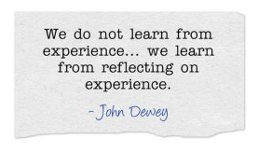
Reflection [3rd marking period] (Example: Create a mural/scrapbook, make a video, write a poem or keep a journal.)
- Reflect on your experience before, during and after the service.
- Choose unique ways to reflect throughout the service.

Demonstration [4th marking period]
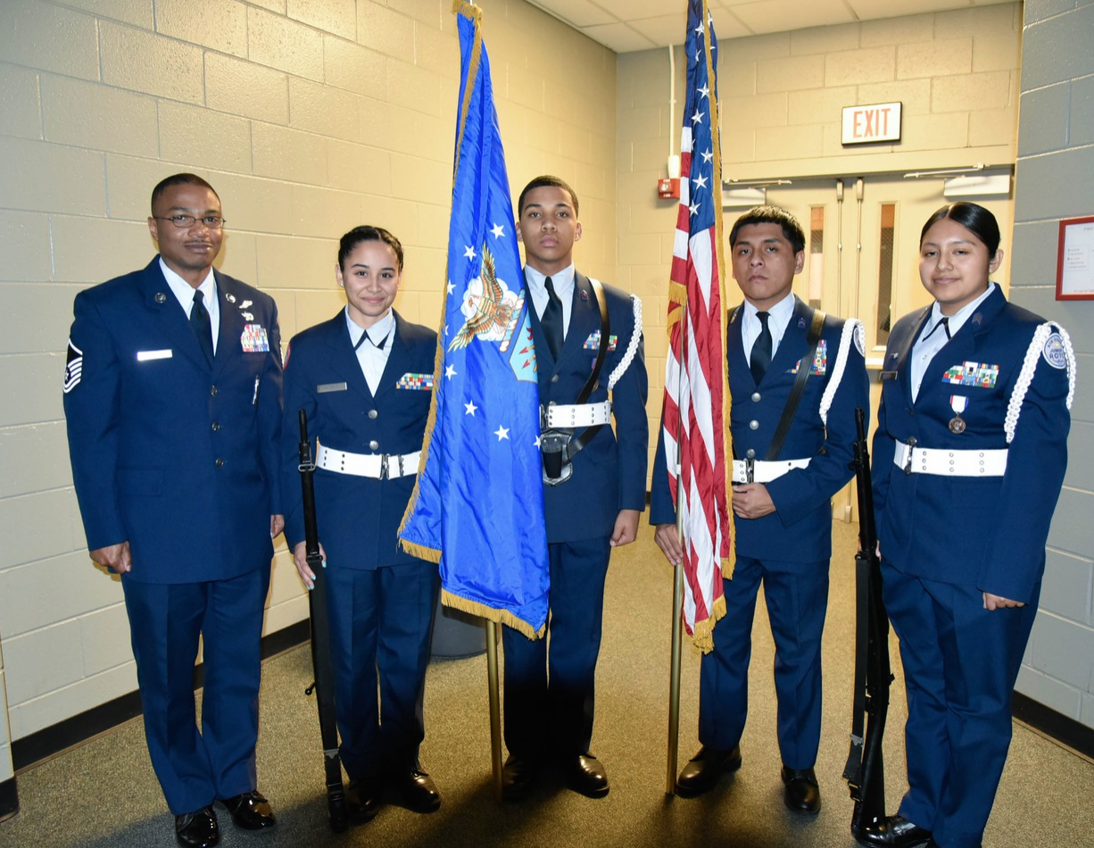
- Share your experience with your family, friends, school, house of worship, community or elected officials.
Vineland High School Service-Learning
Graduation Requirement

Total # of hours required by graduation: 50

Suggested schedule for acquiring hours
Freshman Year: 10 hours
Sophomore Year: 10 hours
Junior Year: 15 hours
Senior Year: 15 hours

SERVICE-LEARNING
WHERE TO START?

Step 1: DECIDE...What REAL WORLD need do you care about? Make sure your service learning hours make a difference. Please refer to the chart below to discover what possible community needs you can address through service-learning. Click on the topics that interest you for more information concerning Community and School Based Partners.

POVERTY/HUNGER | HANDICAPPED | ENVIRONMENT
THE ARTS | LITERACY | HEALTH CARE
CHILDREN | SOCIAL JUSTICE | ANIMALS
ELDERLY | EDUCATION | SPORTS

Step 2: DECIDE...Do you want to focus on ONE community need or SEVERAL community needs? A student may choose to complete all of their service learning hours with one community partner. Or, they may decide to complete their hours by participating in events sponsored by several different community partners and/or VHS throughout the school year.

The choice is YOURS! How will you make a DIFFERENCE in your community?

When choosing where to serve, the following are some conditions to keep in mind:

- All service is given to others freely. Any activity that receives monetary compensation will not be awarded hours.
- Service hours performed to fulfill Vineland High School’s Service Learning graduation requirement must be performed for this purpose exclusively and not be used to fulfill another organization’s requirement.
- Parents may not sign as supervisors of the service of their own children.

SERVICE-LEARNING EXPECTATIONS

EXPECTATIONS OF STUDENTS
1. Find an agency/organization/club that is connected with your interests and will provide
you an opportunity to make positive changes in your school or community.
2. Discuss what you would like to do with your parents and get their approval.
3. Complete the PLANNING FORM and discuss your interests with the agency/organization/
club.
4. Complete the SERVICE LEARNING LOG and submit to School Counselor.
5. Share your experience with your family, friends, school, house of worship, community, or
elected officials.

EXPECTATIONS OF PARENTS
1. Help your child select an agency/organization/club that will provide him/her an
opportunity to positively impact his/her community through service. and complete the
with your child.
2. As your child participates in the service, discuss with him/her what he/she is doing; how it
Is connected with what he/she is learning in school and how it is helping to make positive
changes in the community.

EXPECTATIONS OF SERVICE-LEARNING PROVIDERS
1. Give the student an opportunity to participate in the planning of his/her service learning
experience.
2. Provide a safe and engaging experience.
3. Report any major issues or incidents of inappropriate behavior to administration.
4. Accurately record the number of hours the student engages in the service on the
SERVICE LEARNING LOG.
5. Help the student reflect on the impact of his/her service before, during and after the
service-learning experience.
6. Advocate for other organizations to engage students in service-learning experiences.

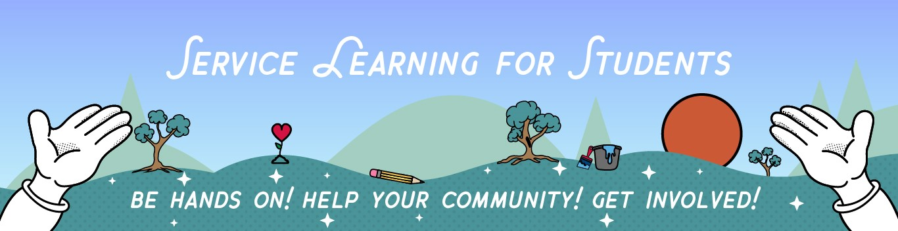

FREQUENTLY ASKED QUESTIONS
Vineland High School Service-Learning
Graduation Requirement

Total # of hours required by graduation: 50

Suggested schedule for acquiring hours
Freshman Year: 10 hours
Sophomore Year: 10 hours
Junior Year: 15 hours
Senior Year: 15 hours
How many hours do I need before graduation?
At this time, each incoming freshman, beginning with the class of 2022 is required to earn a total of 50 hours prior to graduation.

Can I complete all of my required hours for graduation in one year?
Yes. Students may meet their 50 hours of service learning in one year. However, any student that earns 100 service hours will receive a cord to wear at graduation to reward their outstanding volunteerism and service to our community.

Can I complete my required hours in the summer?
Yes. You may begin to acrew hours prior to the start of the upcoming school year. Students may complete their hours over the summer. Freshman Orientation, Transition Camp, campus beautification projects are just a few ways students may earn hours over the summer.

What if I am a new student to VHS?
As a new student to the Vineland School District, you must still earn your Service-Learning hours. You will be required to earn the hours associated with your current school year. You do NOT need to make up any hours you did not earn prior to your enrollment in the Vineland School District. Based upon students entry date, hours will be determined by the VHS administration.

How can I earn my hours?
There are a variety of ways in which to earn hours. The link below highlights a few areas for you to consider. TYPES OF SERVICE LEARNING WITH EXAMPLES

How do I keep track of my hours?
As a student in the Vineland School District, you are responsible for keeping track of your Service-Learning hours using the provided Service - Learning log. These documented hours will be uploaded into Genesis, so you can easily keep track of the hours you have earned towards your graduation requirement. SERVICE LEARNING LOG

What counts as Service Learning?
There are many opportunities both in school and off campus in the community a student at Vineland High School can choose in order to complete Service-Learning hours. As a student attending Vineland High School you need to demonstrate the initiative and the drive to earn your hours. Below is a link to help you during your first years in High School; however, you may decide, as you learn more about Service-Learning to find your own areas of need in the community or in school. WHERE TO START?

What doesn’t count as Service-Learning?
Any service you normally receive payment for does not count towards Service- Learning. Babysitting siblings does not count towards Service Learning.

Why does VHS require Service Learning hours?
In keeping with the mission of Vineland Public Schools, Service Learning provides our students with the opportunity to become knowledgeable, skillful, lifelong learners who become contributing members of society.

Do I need to complete all of my required hours with the same organization?
NO. In keeping with the diversity of our school, the administration team encourages our students to seek a variety Service- Learning opportunities in order to enhance the learning experience. It is imperative students walk away from Service - Learning with a sense of pride and ownership in the activities they accomplish.

Why does the number of required hours increase as students become upperclassmen?
As we get older, our responsibility to our community increases. At Vineland High School we want to foster a sense of duty to the community. It is imperative as our students get older they begin to assume more responsibility within the community.

