Web-Quest The Great Depression – 1930's America

Go to: Teacher Resources - Feature - American Memory Timeline: Great Depression - For Teachers (Library of Congress)

Read the “Overview” and answer below
1. What event started the Great Depression?
2. How many Americans were unemployed during the worst part of the Depression?
3. Explain one effect of the Depression in other parts of the world.
4. What finally brought an end to the Depression in the U.S.?

Go to: Dust Bowl
5. Explain what the Dust Bowl was and its two main causes.
6. Explain what the Dust Bowl caused people in that region to do.

Go to: stock market crash
7. Explain what happened with the stock market and banks to cause the Great Depression:

Go to: 1930's
8. What was the price of a pair of glasses in the 1930's?:
9. What is it now?

Go to: Franklin Delano Roosevelt and the New Deal - For Teachers (Library of Congress)
10. Explain what President Franklin Roosevelt did to restructure America during the Depression. Include an explanation of the New Deal in your answer.

Go to: http://www.u-s-history.com/pages/h1642.html
11. What were Hoovervilles and why were they called that?

Goto: http://www.loc.gov/teachers/classroommaterials/presentationsandactivities/presentations/timeline/depwwii/art/
12. How did people spend their free time during the Depression?
13. How much did a steak cost in the 1930's?
14. What is the feeling you get of life in 1930's America?

Do a Google image search for “Great Depression”
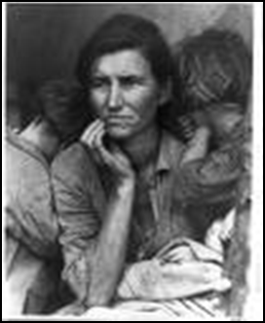

This photo above was taken by Dorothea Lange
15. Why do you think this photo is the MOST famous photo of the Depression?

Go to: Manufacturing Memory: American Popular Music in the 1930's
16. Name the title of a famous song.

Go to: Digital History
17. Read two of the letters from children to the White House. Then imagine yourself in a similar situation.
18. Write a realistic short letter to President or Mrs. Roosevelt asking for a specific kind of help.

